Cambodia | 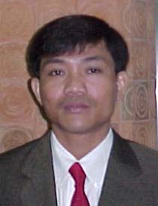 | 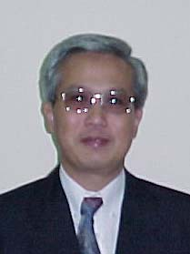 | 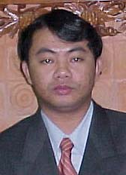 | 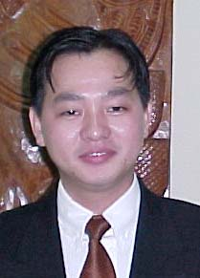 | 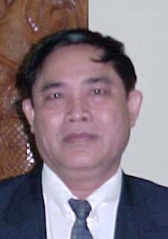
Cambodia | Mr Lam Sovathara 209 | HE Sorasak Pan 306 | Mr Min Chandynavuth 206 | Mr Kong Sophy 314 | HE Chum Iek 304
China | 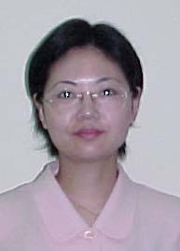 | 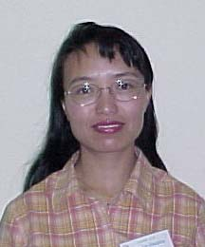 | 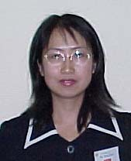 | 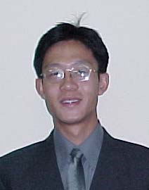 | 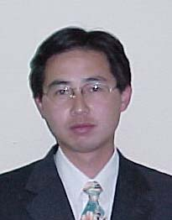
China | Ms Diao Shan 305 | Ms Liu Xiaoping 203 | Ms Wang Suya 302 | Mr Guo Xin 310 | Mr Xiao Sa 213
Lao PDR  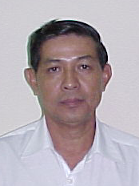 | 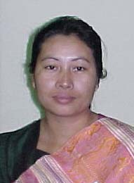 | 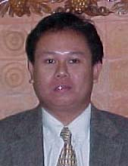 | 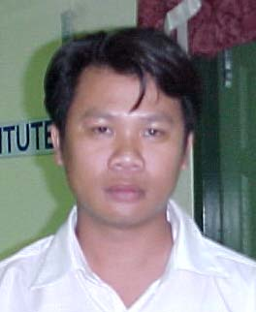 | 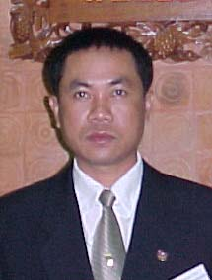
 | Ms Ketkeo Oupalavong 315 | Mr Phongsavanh Phetvorasack 212 | Mr Phoukhao Insomphou 312 | Mr Sengphone Phonamath 308 | Mr Udom Zaw-Raksa 208  (Thailand)
Myanmar | 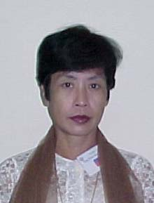 | 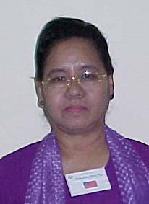 | 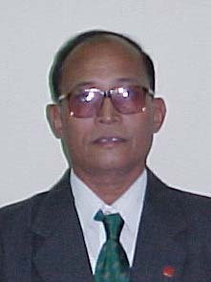 | 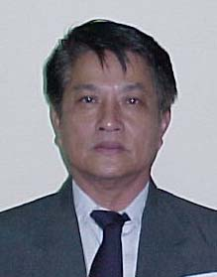 | 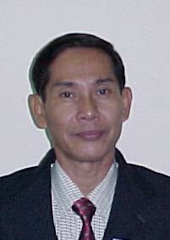
Myanmar | Daw Khin Hla Toe Thu 202 | Daw Khin Khin Hla 205 | U Khin Toe 316 | U Maung Win 210 | U Ye Myint 309
Vietnam | 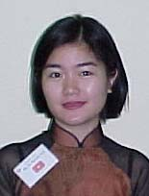 | 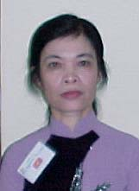 | 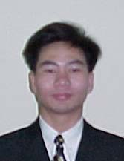 | 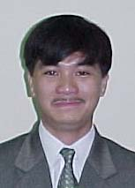 | 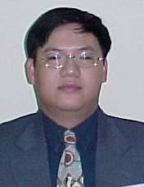
Vietnam | Ms Do Nguyet Anh 318 | Ms Nguyen Thi Lieu 313 | Mr Le Trong Thuy 214 | Mr Luong Dinh Minh 218 | Mr Nguyen Lam 207
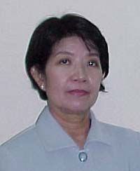
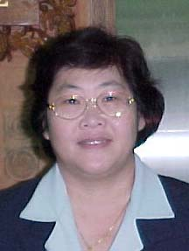
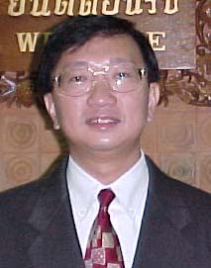
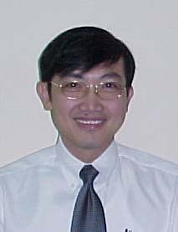
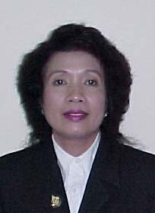Thailand
 | Ms Prangthip Boonsri 211 | Ms Rattanajit Narongvit 303 | Ms Supanee Juangbhanich 204 | Mr Suchart Liengsaengthong 307 | Dr Taweesap Siraprapasiri 216

